1966 Mustang Convertible, VIN 6F08C261687
Professionally restored & repainted Candy Apple Red in 1990 with white top. No rust! Original 289 2-bbl V-8, C4 trans with new converter and seals. Pertronix distributor and coil. Black Deluxe Pony interior with new carpet in interior and trunk. New Autosound radio and antenna, Borgeson P/S with new Eaton pump and hoses. Manual front disks, 2-pot M/C, Shelby 350 conversion rear brakes. Shelby/Arning drop, new dual exhausts, rear springs and shocks, 1” front sway bar. Monte Carlo & Export braces. New Legendary 15 x7 Magnum 500 wheels with new BFG Advantage T/A Sport 205/60R15 91H SL tires. 81,000 miles actual, many other new parts. Forget Bring-A-Trailer, drive it home! $35,000

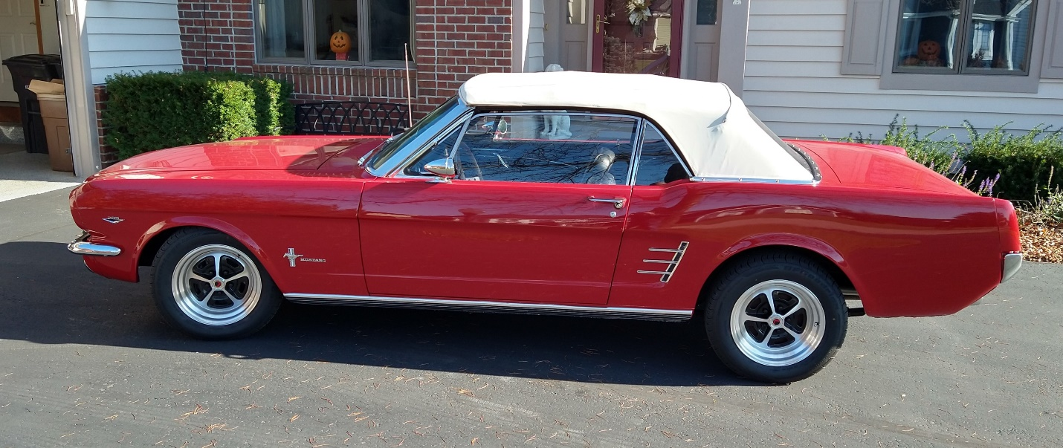

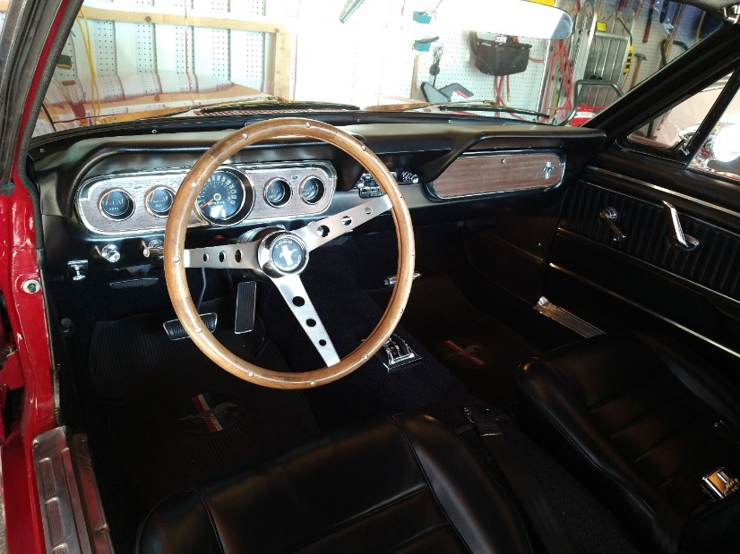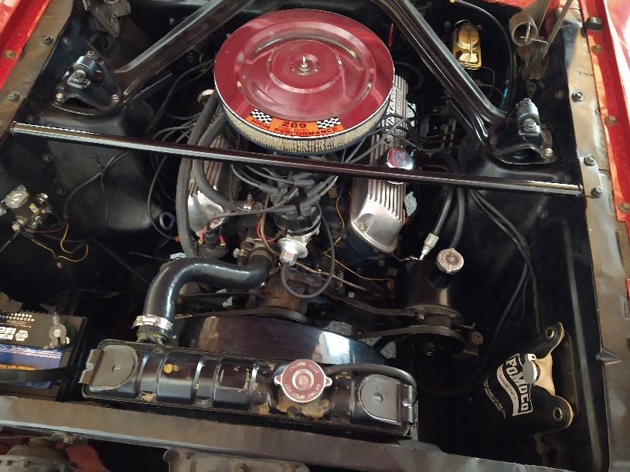

Contact me for a complete list of parts replaced or added at: dmzenge@charter.net

